Piri Reis University
Faculty of Economics and Administrative Sciences
Management Information Systems Department

YBS417
Network Management and Security

Secure Multi-Site Enterprise Network Design for Anatolia Logistics Ltd.

Team Members
Name 1 (Student Number)
Name 2 (Student Number)
Name 3 (Student Number)

Instructions
In this assignment, you will complete a network management and security project using Cisco Packet Tracer. You will design a network with proper subnetting, configure devices, implement security controls, and analyze network traffic. The goal is to show that you can build a structured network, apply security measures, and interpret the behavior of the system. You may work individually or in groups of 2–3, and your submission should include your written report that includes screenshots of your Packet Tracer configurations and a clear explanation of each step.

Important:
Final Report / Presentations Deadline: 07.12.2026

Project Proposal
Prepare a project proposal that clearly describes the project you plan to carry out. You will explain the network you plan to design or the cybersecurity task you plan to perform. The proposal should be clear, realistic, and feasible within the given project period.

Project Report
Present your network design, subnet calculations, device configurations, and the security measures you implemented. Explain your approach step by step, including how you structured the network, the security settings you applied, and the results of your connectivity and traffic analysis.
You will not upload any files. Instead, you will edit the project template provided to you on Microsoft Teams. Modify the cover page, project title, and team member information according to your group. Add your screenshots, explanations, and results directly into that template.

In-class Project Meetings
There will be three in-class project meetings during the semester. Each meeting is worth 10 points and will contribute to the project grade. Attendance, progress, and active participation will be evaluated.

Project: 20% of Grade
- Project Proposal (15 points)
- Project Report (35 points)
- In-class Project Meetings (3 × 10 points = 30 points)
- Presentation (20 points)

PROJECT PROPOSAL
Project Proposal: %25 of Midterm

PROJECT PROPOSAL
Project Title:
Secure Multi-Site Enterprise Network Design for Anatolia Logistics Ltd.
Team Members:
Name 1 (Student Number), Name 2 (Student Number), Name 3 (Student Number)
Project Description:
In this project we will design, configure, secure and test the complete network of a fictional mid-sized logistics company, Anatolia Logistics Ltd., using Cisco Packet Tracer 9.0. The company has a Headquarters (HQ) building and one Branch Office. The two sites are connected with a point-to-point WAN link, and HQ is connected to the Internet through an ISP router. The goal is to build a network that is well structured, efficiently addressed, centrally managed and protected against common LAN attacks.
Objectives:
1) Network design & subnetting: HQ will be divided into five VLANs (IT/Management, HR, Sales, Guest and Servers). The single private block 192.168.10.0/24 will be divided with VLSM so that every department, the Branch LAN and the WAN link receive a correctly sized subnet with minimum address waste.
2) Device configuration: 3 Cisco 2911 routers, 3 Cisco 2960 switches, 3 servers and 12 end devices. Router-on-a-stick inter-VLAN routing, 802.1Q trunks, DHCP pools, OSPF (single area 0) between HQ and the Branch, a default route and PAT (NAT overload) for Internet access, an internal DNS/Web server and a network-management server (Syslog, NTP, TFTP).
3) Security: device hardening (enable secret, password encryption, banner, login block-for), SSH-only remote access limited to the IT VLAN by an ACL, switch port security with sticky MAC, DHCP snooping, PortFast + BPDU Guard, native/unused VLAN hardening, extended ACLs that isolate the Guest VLAN and protect the HR VLAN, and MD5 authentication for OSPF.
4) Testing & traffic analysis: a connectivity test matrix (allowed and blocked flows), security attack tests (rogue device, rogue DHCP server, unauthorized SSH) and Packet Tracer Simulation-mode analysis of ARP, DHCP, DNS, HTTP, ICMP, OSPF and NAT traffic, verified with show commands and Syslog records.
Deliverables & feasibility:
A working Packet Tracer (.pkt) file, an IP addressing/VLSM plan, all device configurations and a report with screenshots. Only devices that exist in Packet Tracer are used, so the project is realistic and can be completed within the semester. Plan: Weeks 1-2 design and subnetting; Weeks 3-4 building the topology and basic configuration; Weeks 5-6 security configuration; Week 7 testing and traffic analysis; Week 8 final report and presentation.

PROJECT REPORT
Project Summary: %25 of Final
PROJECT SUMMARY
Your project summary should clearly describe the key features of the project, specify the technologies used, and outline any challenges encountered during the process.
Project Title:
Secure Multi-Site Enterprise Network Design for Anatolia Logistics Ltd.
Team Members:
Name 1 (Student Number), Name 2 (Student Number), Name 3 (Student Number)
Project Summary:
We designed and implemented a secure two-site enterprise network for the fictional company Anatolia Logistics Ltd. in Cisco Packet Tracer 9.0. The Headquarters is segmented into five VLANs (IT/Management 10, HR 20, Sales 30, Guest 40, Servers 50) and is connected to a Branch Office (VLAN 60) and to a simulated ISP.
Key features:
- One /24 block (192.168.10.0/24) divided with VLSM into seven subnets (/26, /26, /27, /27, /27, /28, /30); 244 of 256 addresses are allocated and 12 are kept spare for growth.
- Router-on-a-stick inter-VLAN routing, 802.1Q trunks, router-based DHCP for every user VLAN, OSPF area 0 between HQ and the Branch with a redistributed default route, and PAT to the Internet.
- Internal DNS + Web server (intranet.anatolia.local) and a management server that collects Syslog messages, provides NTP time and stores configuration backups via TFTP.
- Layered security: hardened device access (SSH v2 only, local AAA, ACL-restricted VTY, login block-for, encrypted passwords, banners), switch security (port security with sticky MAC, DHCP snooping, BPDU Guard, black-hole VLAN for unused ports, non-default native VLAN, DTP disabled), traffic filtering (GUEST-IN and HR-PROTECT extended ACLs) and OSPF MD5 authentication.
- Verification through a 16-test connectivity matrix and Simulation-mode traffic analysis (DHCP DORA, ARP, DNS, HTTP, OSPF, NAT translations and ACL drops).
Technologies used:
Cisco Packet Tracer 9.0, Cisco IOS (2911 routers, 2960-24TT switches), VLAN/802.1Q, VLSM, DHCP, OSPFv2, NAT/PAT, standard & extended ACLs, SSH v2, Port Security, DHCP Snooping, STP PortFast/BPDU Guard, DNS, HTTP, Syslog, NTP, TFTP.
Challenges encountered:
(1) After enabling DHCP snooping the PCs stopped receiving addresses because the switch inserted DHCP option 82; this was solved with 'no ip dhcp snooping information option' and trusted uplinks. (2) The outbound HR ACL first blocked return traffic of sessions started by HR; we added 'established' and 'echo-reply' entries. (3) The Guest ACL also blocked DNS, so guests could not resolve Internet names; an explicit DNS permit was added above the deny statement. (4) Replacing a PC on a secured port put the port into err-disabled state, which required an administrative recovery procedure. (5) Choosing ACL placement (inbound near the source vs. outbound near the destination) required careful planning so that legitimate traffic was not affected.

DETAILED PROJECT REPORT
Secure Multi-Site Enterprise Network Design for Anatolia Logistics Ltd.

1. Introduction and Scenario
Anatolia Logistics Ltd. is a fictional logistics company with a Headquarters (HQ) building in Istanbul and a small Branch Office. The company needs a network that separates its departments, gives every user automatic addressing and Internet access, lets the IT team manage all devices securely from one place, and protects sensitive departments (HR) and the internal network from guest users and from common LAN attacks.
The network was built and tested completely in Cisco Packet Tracer 9.0. The design follows four goals:
– Segmentation: each department is placed in its own VLAN and IP subnet, which limits broadcast domains and allows filtering between departments.
– Efficiency: one private /24 block is divided with VLSM so that each subnet is sized to its real need.
– Manageability: centralized DHCP, Syslog, NTP, configuration backup (TFTP) and SSH-based remote management.
– Security (defense in depth): controls on the device, switch-port, VLAN, routing-protocol and traffic-filtering layers.
Table 1 lists the requirements given for each network segment.
Segment | VLAN | Users / devices | Notes
IT / Management | 10 | 25 hosts | Network admins; only VLAN allowed to manage devices
Human Resources | 20 | 20 hosts | Confidential data; must be isolated from Sales/Guest/Branch
Sales | 30 | 40 hosts | Normal users; intranet + Internet
Guest | 40 | 50 hosts | Visitors; Internet only, no access to internal network
Servers | 50 | 8 hosts | Web/DNS server, management server (Syslog/NTP/TFTP)
Branch Office LAN | 60 | 18 hosts | Remote site; reaches HQ servers over WAN
HQ - Branch WAN | - | 2 hosts | Point-to-point router link
Table 1 - Network requirements

2. Network Topology
Figure 1 shows the designed topology. HQ-R1 is the central router: it performs inter-VLAN routing for the five HQ VLANs (router-on-a-stick over an 802.1Q trunk), connects to BRANCH-R2 over a /30 WAN link running OSPF, and connects to the ISP router, where PAT translates internal addresses to the public address 203.0.113.2. HQ-SW1 serves IT, HR and the servers; HQ-SW2 serves Sales and Guest users and is connected to HQ-SW1 with a trunk.
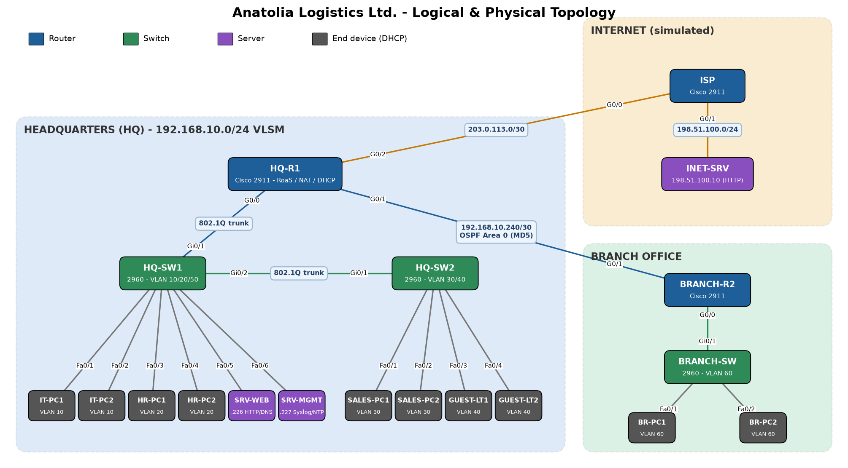
Figure 1 - Anatolia Logistics network topology
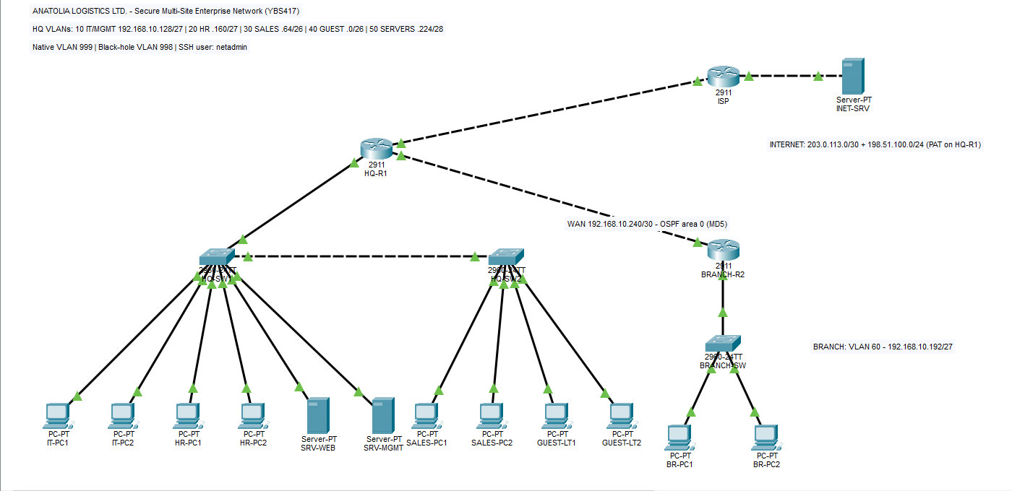
Screenshot 1 - Complete topology in the Packet Tracer logical workspace
Device | Model | Role
HQ-R1 | Cisco 2911 | Inter-VLAN routing, DHCP server, OSPF, default route, NAT/PAT, ACLs
BRANCH-R2 | Cisco 2911 | Branch gateway, Branch DHCP, OSPF
ISP | Cisco 2911 | Simulated Internet provider
HQ-SW1 | Cisco 2960-24TT | Access switch: VLAN 10, 20, 50; trunk to HQ-R1 and HQ-SW2
HQ-SW2 | Cisco 2960-24TT | Access switch: VLAN 30, 40
BRANCH-SW | Cisco 2960-24TT | Branch access switch: VLAN 60
SRV-WEB | Server-PT | HTTP (intranet) + DNS
SRV-MGMT | Server-PT | Syslog, NTP, TFTP (config backup)
INET-SRV | Server-PT | Public web server on the Internet side
IT-PC1/2, HR-PC1/2, SALES-PC1/2, BR-PC1/2 | PC-PT | End users (DHCP clients)
GUEST-LT1/2 | PC-PT | Guest devices (DHCP clients)
Table 2 - Device inventory
Link | Side A | Side B | Cable
HQ-R1 - HQ-SW1 | HQ-R1 G0/0 | HQ-SW1 Gi0/1 | Copper straight-through
HQ-SW1 - HQ-SW2 | HQ-SW1 Gi0/2 | HQ-SW2 Gi0/1 | Copper cross-over
HQ-R1 - BRANCH-R2 | HQ-R1 G0/1 | BRANCH-R2 G0/1 | Copper cross-over
HQ-R1 - ISP | HQ-R1 G0/2 | ISP G0/0 | Copper cross-over
ISP - INET-SRV | ISP G0/1 | INET-SRV Fa0 | Copper cross-over
BRANCH-R2 - BRANCH-SW | BRANCH-R2 G0/0 | BRANCH-SW Gi0/1 | Copper straight-through
HQ-SW1 access | Fa0/1-2 IT, Fa0/3-4 HR, Fa0/5 SRV-WEB, Fa0/6 SRV-MGMT | End devices | Copper straight-through
HQ-SW2 access | Fa0/1-2 Sales, Fa0/3-4 Guest | End devices | Copper straight-through
BRANCH-SW access | Fa0/1-2 Branch PCs | End devices | Copper straight-through
Table 3 - Cabling plan

3. IP Addressing and Subnet Calculations (VLSM)

3.1 Method
The company was given the private block 192.168.10.0/24 (256 addresses). Fixed-length subnetting would waste addresses (eight /27 subnets of 30 hosts could not fit the 50-host Guest VLAN, and a /30 WAN link would waste a whole /27). Therefore Variable Length Subnet Masking (VLSM) was used with these steps:
1. List all segments and the number of hosts each one needs.
2. Sort the segments from the largest to the smallest.
3. For each segment, find the smallest number of host bits h that satisfies 2^h - 2 >= required hosts. The prefix is /(32 - h) and the block size is 2^h.
4. Allocate the subnets one after another starting from 192.168.10.0, so every block starts on a multiple of its own size.

3.2 Host-bit calculation
Segment (sorted) | Required hosts | Host bits (h) | 2^h - 2 (usable) | Prefix | Mask | Block size
Guest (VLAN 40) | 50 | 6 | 62 | /26 | 255.255.255.192 | 64
Sales (VLAN 30) | 40 | 6 | 62 | /26 | 255.255.255.192 | 64
IT / Mgmt (VLAN 10) | 25 | 5 | 30 | /27 | 255.255.255.224 | 32
HR (VLAN 20) | 20 | 5 | 30 | /27 | 255.255.255.224 | 32
Branch LAN (VLAN 60) | 18 | 5 | 30 | /27 | 255.255.255.224 | 32
Servers (VLAN 50) | 8 | 4 | 14 | /28 | 255.255.255.240 | 16
HQ-Branch WAN | 2 | 2 | 2 | /30 | 255.255.255.252 | 4
Table 4 - Host bits and prefix for every segment
Worked example (Guest VLAN): 50 hosts are needed. 2^5 - 2 = 30 is not enough, 2^6 - 2 = 62 is enough, so h = 6. The prefix is 32 - 6 = /26, the mask is 255.255.255.192 and the block size is 64. The first block is 192.168.10.0 - 192.168.10.63: network 192.168.10.0, first usable .1 (gateway), last usable .62, broadcast .63. The next subnet (Sales) therefore starts at 192.168.10.64.
Worked example (WAN): 2 hosts are needed. 2^2 - 2 = 2, so h = 2 and the prefix is /30 (block size 4). The block 192.168.10.240/30 gives .241 to HQ-R1, .242 to BRANCH-R2 and .243 is the broadcast address.

3.3 VLSM allocation table
Segment | Network / Prefix | Usable range | Broadcast | Gateway | Wildcard
Guest (40) | 192.168.10.0/26 | .1 - .62 | 192.168.10.63 | 192.168.10.1 | 0.0.0.63
Sales (30) | 192.168.10.64/26 | .65 - .126 | 192.168.10.127 | 192.168.10.65 | 0.0.0.63
IT / Mgmt (10) | 192.168.10.128/27 | .129 - .158 | 192.168.10.159 | 192.168.10.129 | 0.0.0.31
HR (20) | 192.168.10.160/27 | .161 - .190 | 192.168.10.191 | 192.168.10.161 | 0.0.0.31
Branch (60) | 192.168.10.192/27 | .193 - .222 | 192.168.10.223 | 192.168.10.193 | 0.0.0.31
Servers (50) | 192.168.10.224/28 | .225 - .238 | 192.168.10.239 | 192.168.10.225 | 0.0.0.15
HQ-Branch WAN | 192.168.10.240/30 | .241 - .242 | 192.168.10.243 | - | 0.0.0.3
Spare (future) | 192.168.10.244/30, 192.168.10.248/29 | - | - | - | -
Table 5 - VLSM allocation of 192.168.10.0/24
Address utilization: 64 + 64 + 32 + 32 + 32 + 16 + 4 = 244 of 256 addresses are allocated, and 12 addresses (one /30 and one /29) are kept for future point-to-point links or small segments. Public addressing: 203.0.113.0/30 between HQ-R1 and the ISP, and 198.51.100.0/24 for the simulated Internet server.

3.4 Device addressing table
Device | Interface | IP address | Subnet mask | Default gateway
HQ-R1 | G0/0.10 | 192.168.10.129 | 255.255.255.224 | -
HQ-R1 | G0/0.20 | 192.168.10.161 | 255.255.255.224 | -
HQ-R1 | G0/0.30 | 192.168.10.65 | 255.255.255.192 | -
HQ-R1 | G0/0.40 | 192.168.10.1 | 255.255.255.192 | -
HQ-R1 | G0/0.50 | 192.168.10.225 | 255.255.255.240 | -
HQ-R1 | G0/1 | 192.168.10.241 | 255.255.255.252 | -
HQ-R1 | G0/2 | 203.0.113.2 | 255.255.255.252 | -
BRANCH-R2 | G0/0 | 192.168.10.193 | 255.255.255.224 | -
BRANCH-R2 | G0/1 | 192.168.10.242 | 255.255.255.252 | -
ISP | G0/0 / G0/1 | 203.0.113.1 / 198.51.100.1 | /30 / /24 | -
HQ-SW1 | VLAN 10 | 192.168.10.130 | 255.255.255.224 | 192.168.10.129
HQ-SW2 | VLAN 10 | 192.168.10.131 | 255.255.255.224 | 192.168.10.129
BRANCH-SW | VLAN 60 | 192.168.10.194 | 255.255.255.224 | 192.168.10.193
SRV-WEB | Fa0 | 192.168.10.226 | 255.255.255.240 | 192.168.10.225
SRV-MGMT | Fa0 | 192.168.10.227 | 255.255.255.240 | 192.168.10.225
INET-SRV | Fa0 | 198.51.100.10 | 255.255.255.0 | 198.51.100.1
All PCs / laptops | NIC | DHCP | DHCP | DHCP
Table 6 - Device addressing
Statically addressed devices (gateways, switch management interfaces, servers) are excluded from the DHCP pools. For example, in VLAN 10 the range .129-.139 is excluded, so DHCP clients receive addresses starting from 192.168.10.140.

4. VLAN and Switch Configuration
VLAN | Name | HQ-SW1 ports | HQ-SW2 ports | BRANCH-SW ports
10 | IT-MGMT | Fa0/1-2 (+ SVI .130) | SVI .131 only | -
20 | HR | Fa0/3-4 | - | -
30 | SALES | - | Fa0/1-2 | -
40 | GUEST | - | Fa0/3-4 | -
50 | SERVERS | Fa0/5-6 | - | -
60 | BRANCH-USERS | - | - | Fa0/1-2, Gi0/1
998 | BLACKHOLE | Fa0/7-24 (shutdown) | Fa0/5-24, Gi0/2 (shutdown) | Fa0/3-24, Gi0/2 (shutdown)
999 | NATIVE | Trunk native VLAN | Trunk native VLAN | -
Table 7 - VLAN plan and port assignment
The VLANs are created on each switch and the access ports are assigned statically. The links HQ-SW1 to HQ-R1 and HQ-SW1 to HQ-SW2 are configured as 802.1Q trunks. Only the required VLANs are allowed on each trunk (manual pruning), DTP negotiation is disabled and the native VLAN is changed to an unused VLAN (999).
HQ-SW1(config)# vlan 10
HQ-SW1(config-vlan)# name IT-MGMT
... (VLAN 20, 30, 40, 50, 998, 999 created the same way)
HQ-SW1(config)# interface GigabitEthernet0/1
HQ-SW1(config-if)# switchport mode trunk
HQ-SW1(config-if)# switchport trunk native vlan 999
HQ-SW1(config-if)# switchport trunk allowed vlan 10,20,30,40,50,999
HQ-SW1(config-if)# switchport nonegotiate
HQ-SW1(config)# interface range FastEthernet0/3 - 4
HQ-SW1(config-if-range)# switchport mode access
HQ-SW1(config-if-range)# switchport access vlan 20
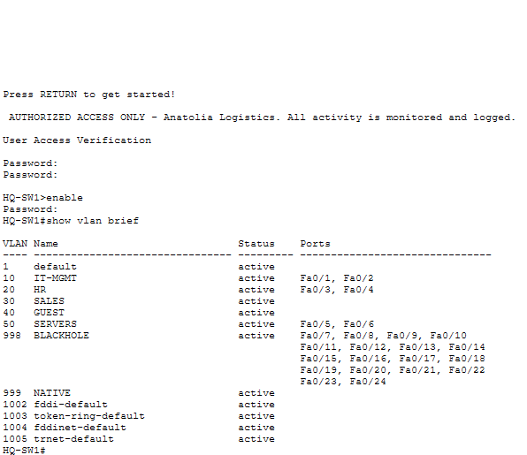
Screenshot 2 - HQ-SW1 'show vlan brief' output
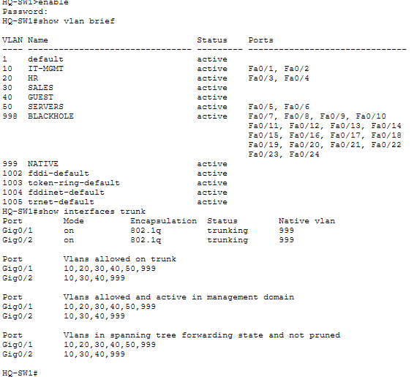
Screenshot 3 - HQ-SW1 'show interfaces trunk' output (native VLAN 999, allowed VLANs)
Each switch has a management SVI in VLAN 10 (or 60 at the Branch) and a default gateway, so that the IT team can manage it remotely with SSH. VLAN 1 is shut down because it is the default VLAN and a common attack target.

5. Router Configuration

5.1 Inter-VLAN routing (router-on-a-stick)
HQ-R1 G0/0 is divided into one sub-interface per VLAN. Each sub-interface uses 802.1Q encapsulation with the VLAN ID and holds the default gateway address of that VLAN. When a frame arrives from the trunk with VLAN tag 30, the router removes the tag, routes the packet and sends it back on the trunk with the tag of the destination VLAN.
HQ-R1(config)# interface GigabitEthernet0/0.30
HQ-R1(config-subif)# description VLAN30-SALES
HQ-R1(config-subif)# encapsulation dot1Q 30
HQ-R1(config-subif)# ip address 192.168.10.65 255.255.255.192
HQ-R1(config)# interface GigabitEthernet0/0.999
HQ-R1(config-subif)# encapsulation dot1Q 999 native

5.2 DHCP
HQ-R1 is the DHCP server for VLANs 10, 20, 30 and 40, and BRANCH-R2 is the DHCP server for the Branch LAN. Every pool gives the client its gateway, the internal DNS server (192.168.10.226) and the domain name anatolia.local. Servers use static addresses.
HQ-R1(config)# ip dhcp excluded-address 192.168.10.65 192.168.10.74
HQ-R1(config)# ip dhcp pool VLAN30-SALES
HQ-R1(dhcp-config)# network 192.168.10.64 255.255.255.192
HQ-R1(dhcp-config)# default-router 192.168.10.65
HQ-R1(dhcp-config)# dns-server 192.168.10.226
HQ-R1(dhcp-config)# domain-name anatolia.local
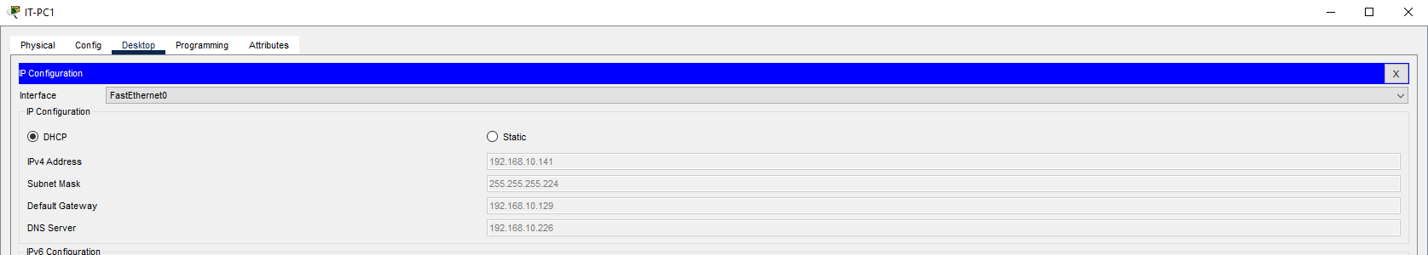
Screenshot 4 - A PC's IP Configuration window showing an address received by DHCP
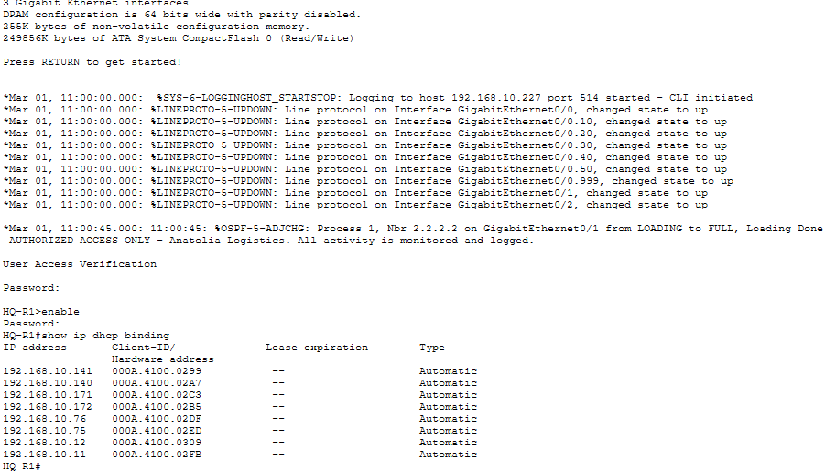
Screenshot 5 - HQ-R1 'show ip dhcp binding' output

5.3 Dynamic routing - OSPF
OSPFv2 (process 1, area 0) connects HQ and the Branch. 'passive-interface default' stops OSPF hello messages on all LAN interfaces, so users cannot see or inject routing updates; only the WAN interface G0/1 is active. HQ-R1 has a static default route to the ISP and advertises it to the Branch with 'default-information originate'.
HQ-R1(config)# ip route 0.0.0.0 0.0.0.0 203.0.113.1
HQ-R1(config)# router ospf 1
HQ-R1(config-router)# router-id 1.1.1.1
HQ-R1(config-router)# network 192.168.10.0 0.0.0.255 area 0
HQ-R1(config-router)# passive-interface default
HQ-R1(config-router)# no passive-interface GigabitEthernet0/1
HQ-R1(config-router)# default-information originate
BRANCH-R2(config)# router ospf 1
BRANCH-R2(config-router)# router-id 2.2.2.2
BRANCH-R2(config-router)# network 192.168.10.192 0.0.0.31 area 0
BRANCH-R2(config-router)# network 192.168.10.240 0.0.0.3 area 0
BRANCH-R2(config-router)# passive-interface GigabitEthernet0/0
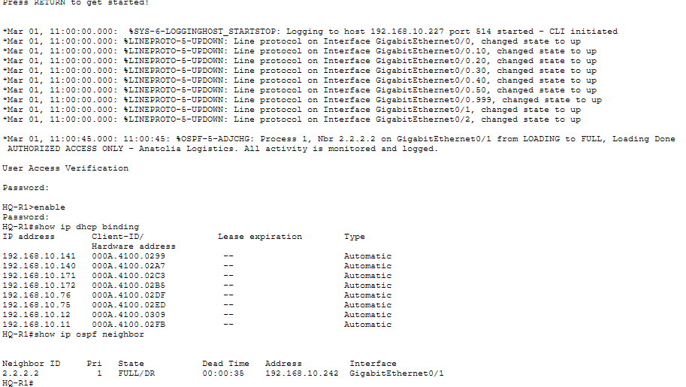
Screenshot 6 - 'show ip ospf neighbor' on HQ-R1 (BRANCH-R2 in FULL state)
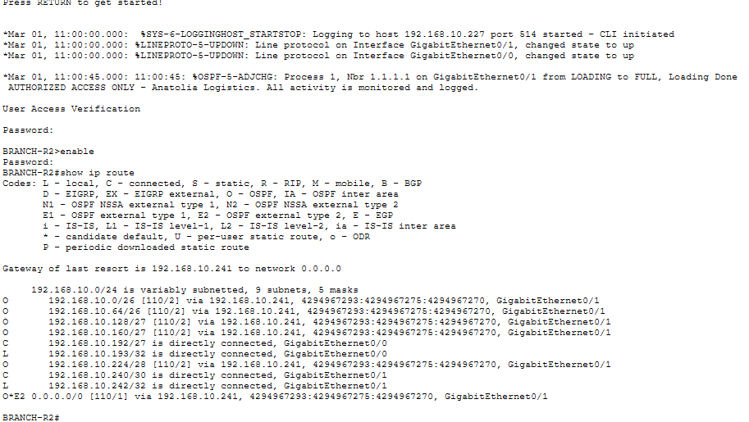
Screenshot 7 - 'show ip route' on BRANCH-R2 (O routes and the O*E2 default route)

5.4 Internet access - NAT/PAT
Private addresses cannot be routed on the Internet, so HQ-R1 uses PAT (NAT overload): all internal hosts, including the Branch, share the single public address of G0/2 (203.0.113.2), and port numbers keep the sessions apart. The ISP router has no routes to the private network, which shows that NAT is really needed.
HQ-R1(config)# ip access-list standard NAT-INSIDE
HQ-R1(config-std-nacl)# permit 192.168.10.0 0.0.0.255
HQ-R1(config)# ip nat inside source list NAT-INSIDE interface GigabitEthernet0/2 overload
HQ-R1(config)# interface GigabitEthernet0/2
HQ-R1(config-if)# ip nat outside
(all sub-interfaces and G0/1 are 'ip nat inside')
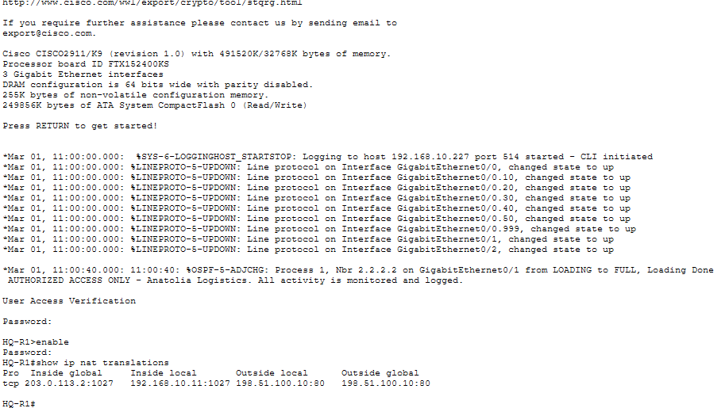
Screenshot 8 - 'show ip nat translations' on HQ-R1 after browsing www.internet.com

6. Network Services and Network Management
Server | Service | Configuration
SRV-WEB 192.168.10.226 | HTTP | Intranet page 'Anatolia Logistics Intranet' (index.html edited)
SRV-WEB 192.168.10.226 | DNS | A records: intranet.anatolia.local -> 192.168.10.226; www.internet.com -> 198.51.100.10
SRV-MGMT 192.168.10.227 | Syslog | Receives log messages from HQ-R1 and BRANCH-R2 ('logging host')
SRV-MGMT 192.168.10.227 | NTP | Time source for the routers ('ntp server'), correct timestamps in logs
SRV-MGMT 192.168.10.227 | TFTP | Stores configuration backups ('copy running-config tftp')
INET-SRV 198.51.100.10 | HTTP | Public web page used to test Internet access through NAT
Table 8 - Server services
Network management is centralized on SRV-MGMT. With 'service timestamps log datetime msec' and NTP, every Syslog message has a correct time stamp, which is important when security events are investigated. Running configurations are backed up to the TFTP server so that a device can be restored quickly after a failure:
HQ-R1# copy running-config tftp:
Address or name of remote host []? 192.168.10.227
Destination filename [HQ-R1-confg]? HQ-R1-confg
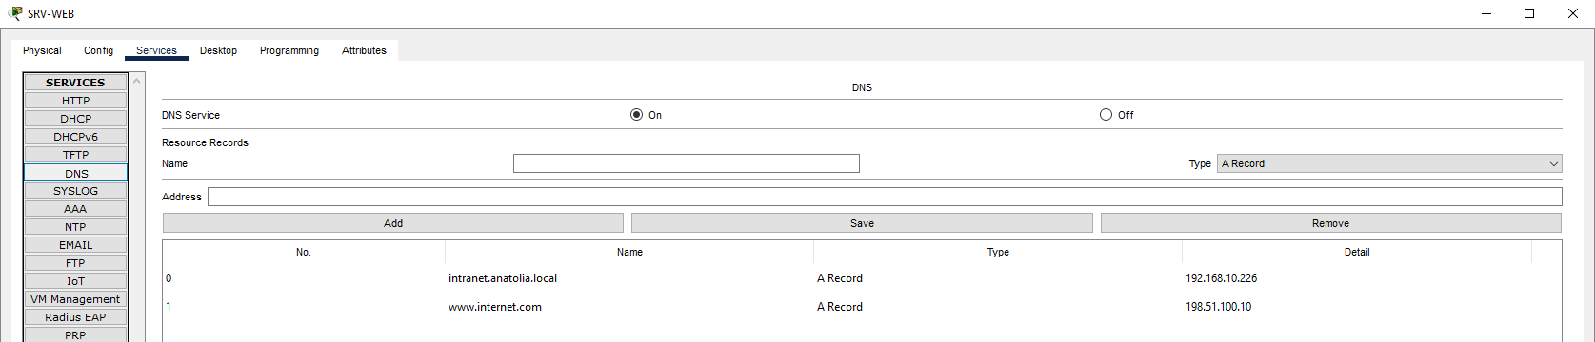
Screenshot 9 - SRV-WEB DNS service with the A records
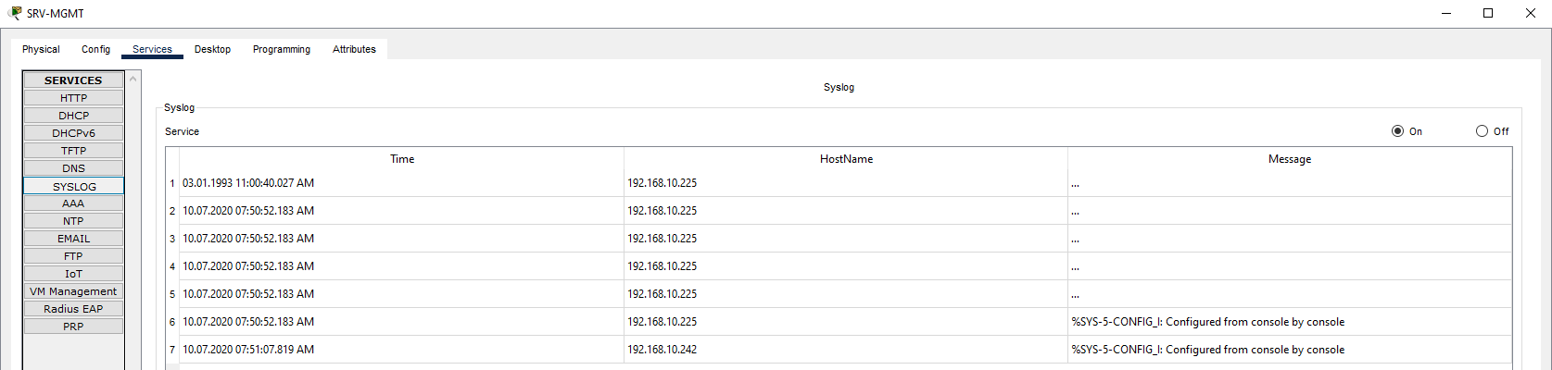
Screenshot 10 - SRV-MGMT Syslog service showing messages from the routers
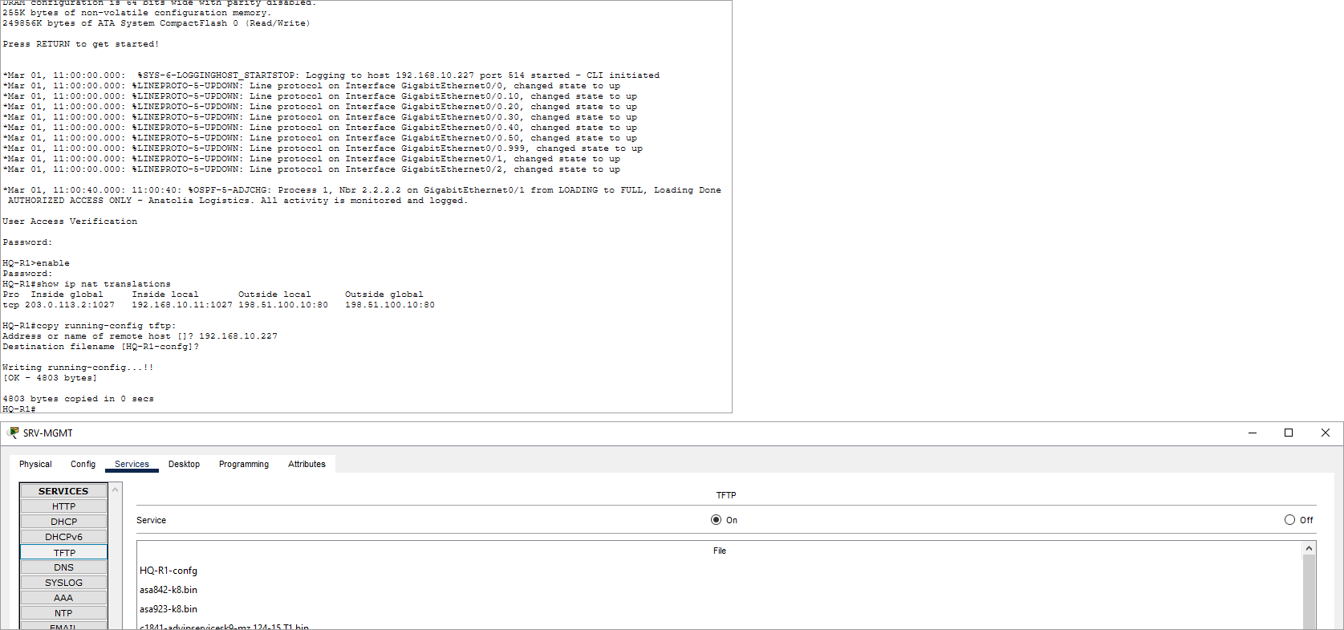
Screenshot 11 - SRV-MGMT TFTP service listing the backed-up configuration files

7. Security Implementation
Security was applied in layers (defense in depth). Table 9 summarizes each threat and the control used against it.
Threat | Control | Where
Password theft / brute force | enable secret, service password-encryption, min-length 10, login block-for 120 attempts 3 within 60 | All routers / switches
Sniffing of management traffic | SSH v2 only (Telnet disabled), local user database, exec-timeout | All routers / switches
Unauthorized management access | Standard ACL 10 on VTY lines - only VLAN 10 (IT) | All routers / switches
Rogue device / MAC flooding | Port security: max 1 MAC, sticky, violation shutdown | All access ports
Rogue DHCP server | DHCP snooping, only uplinks trusted | All switches
STP manipulation / loops | PortFast + BPDU Guard on access ports | All switches
VLAN hopping | Native VLAN 999, DTP disabled (nonegotiate), allowed-VLAN list | Trunks
Unused ports | Assigned to black-hole VLAN 998 and shut down | All switches
Guest access to internal data | Extended ACL GUEST-IN (inbound, VLAN 40) | HQ-R1 G0/0.40
Access to HR data | Extended ACL HR-PROTECT (outbound, VLAN 20) | HQ-R1 G0/0.20
Fake routing updates | OSPF MD5 authentication + passive interfaces | HQ-R1, BRANCH-R2
Exposure of internal addresses / topology | PAT, CDP disabled toward the ISP | HQ-R1 G0/2
Legal / deterrence | MOTD warning banner | All devices
Table 9 - Threats and security controls

7.1 Device hardening
HQ-R1(config)# security passwords min-length 10
HQ-R1(config)# enable secret Ent3rpr1se!
HQ-R1(config)# service password-encryption
HQ-R1(config)# login block-for 120 attempts 3 within 60
HQ-R1(config)# banner motd # AUTHORIZED ACCESS ONLY - Anatolia Logistics. All activity is monitored and logged. #
HQ-R1(config)# line console 0
HQ-R1(config-line)# password C0ns0leP@ss
HQ-R1(config-line)# login
HQ-R1(config-line)# exec-timeout 5 0
'enable secret' stores the privileged password as a hash, and 'service password-encryption' hides the other passwords in the configuration. 'login block-for' blocks all login attempts for 120 seconds when 3 attempts fail within 60 seconds, which stops brute-force attacks.

7.2 Secure remote management (SSH + VTY ACL)
HQ-R1(config)# ip domain-name anatolia.local
HQ-R1(config)# username netadmin privilege 15 secret Adm1nP@ss!
HQ-R1(config)# crypto key generate rsa general-keys modulus 1024
HQ-R1(config)# ip ssh version 2
HQ-R1(config)# access-list 10 permit 192.168.10.128 0.0.0.31
HQ-R1(config)# line vty 0 15
HQ-R1(config-line)# login local
HQ-R1(config-line)# transport input ssh
HQ-R1(config-line)# access-class 10 in
Telnet sends passwords in clear text, so only SSH version 2 is accepted. The 'access-class 10 in' command makes sure that only hosts in the IT/Management VLAN (192.168.10.128/27) can even open a management session.
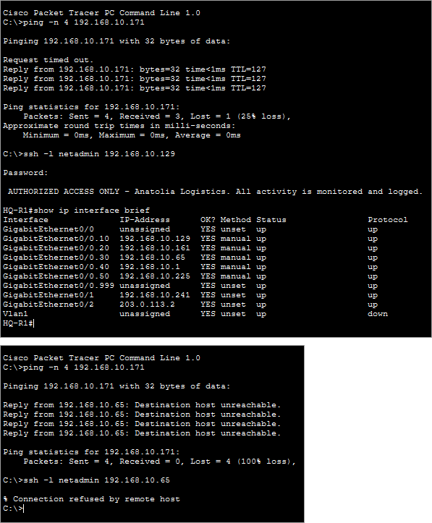
Screenshot 12 - Successful SSH from IT-PC1 ('ssh -l netadmin 192.168.10.129') and refused SSH from SALES-PC1

7.3 Port security
HQ-SW1(config)# interface range FastEthernet0/1 - 2
HQ-SW1(config-if-range)# switchport port-security
HQ-SW1(config-if-range)# switchport port-security maximum 1
HQ-SW1(config-if-range)# switchport port-security mac-address sticky
HQ-SW1(config-if-range)# switchport port-security violation shutdown
Every access port learns the MAC address of its first device and saves it (sticky). If another device is connected, the port goes into err-disabled state and a Syslog message is generated. This prevents rogue devices and MAC-flooding attacks.
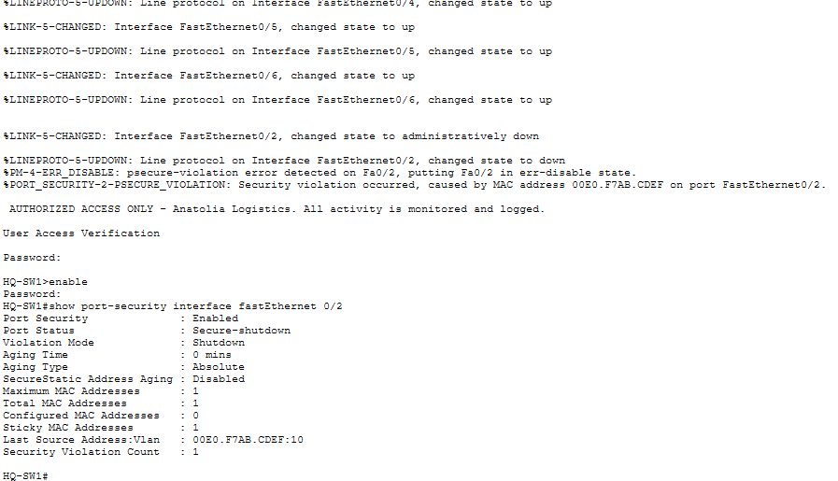
Screenshot 13 - 'show port-security interface fa0/1' after a violation (Secure-shutdown, violation count 1)

7.4 DHCP snooping
HQ-SW1(config)# ip dhcp snooping
HQ-SW1(config)# ip dhcp snooping vlan 10,20,30,40,50
HQ-SW1(config)# no ip dhcp snooping information option
HQ-SW1(config)# interface GigabitEthernet0/1
HQ-SW1(config-if)# ip dhcp snooping trust
Only the uplink ports toward the real DHCP server (HQ-R1) are trusted. DHCP OFFER/ACK messages that arrive on any other port are dropped, so a rogue DHCP server cannot give users a fake gateway or DNS server (man-in-the-middle attack).
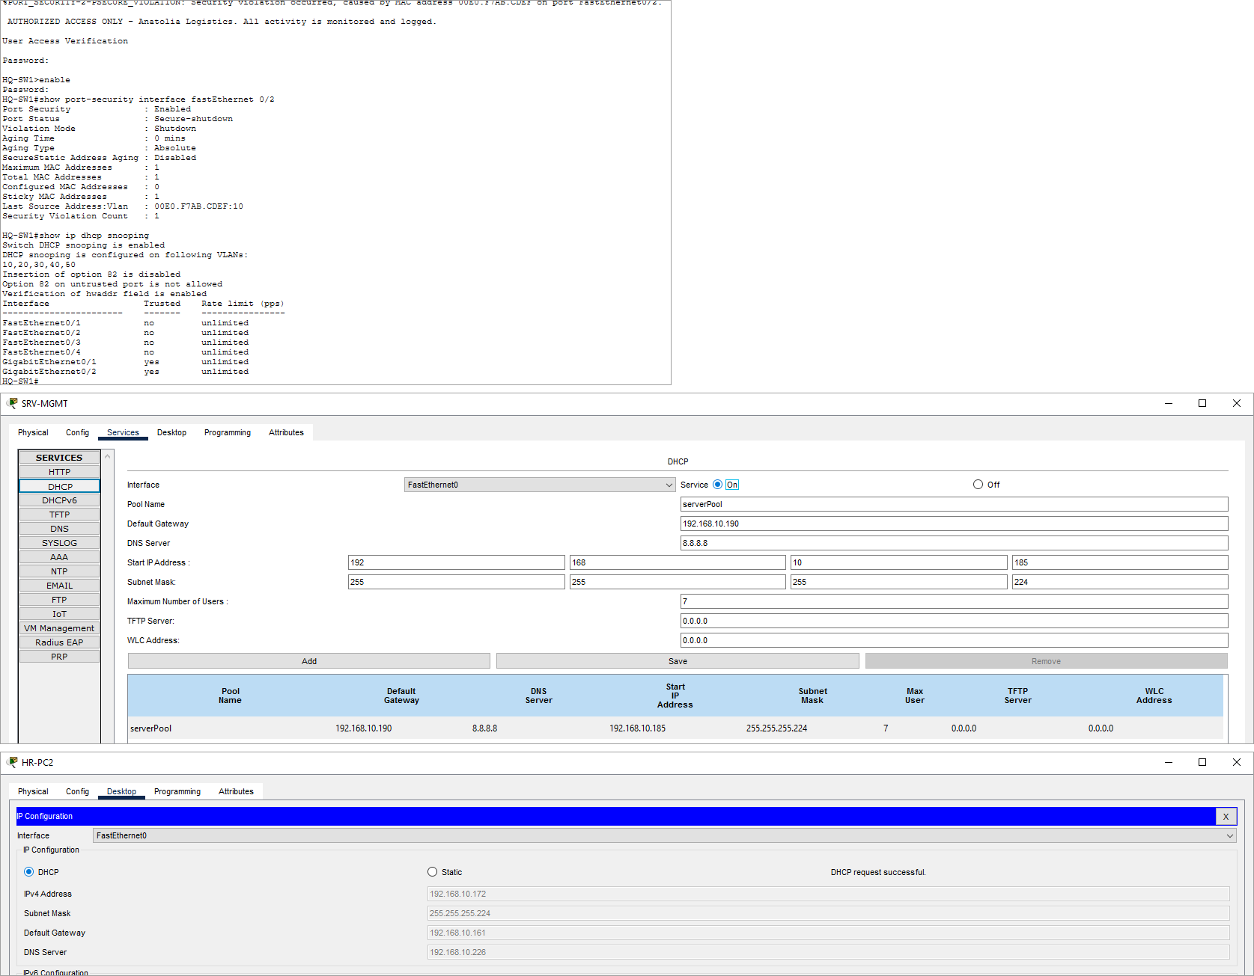
Screenshot 14 - 'show ip dhcp snooping' output and rogue DHCP test result

7.5 Spanning Tree protection and VLAN hardening
HQ-SW1(config-if-range)# spanning-tree portfast
HQ-SW1(config-if-range)# spanning-tree bpduguard enable
HQ-SW1(config)# interface range FastEthernet0/7 - 24
HQ-SW1(config-if-range)# switchport access vlan 998
HQ-SW1(config-if-range)# shutdown
PortFast lets end devices start forwarding immediately, and BPDU Guard shuts the port down if a switch is connected to it, which protects the STP topology. Unused ports are shut down and placed in a black-hole VLAN, and trunks use a non-default native VLAN with DTP disabled to prevent VLAN-hopping attacks.

7.6 Access Control Lists
GUEST-IN is an extended ACL applied inbound on the Guest sub-interface, as close as possible to the source. Guests may get an address (DHCP), resolve names with the internal DNS server and ping their own gateway, but every other packet toward the internal 192.168.10.0/24 network is denied; all other traffic (the Internet) is permitted.
ip access-list extended GUEST-IN
permit udp any any eq 67
permit udp 192.168.10.0 0.0.0.63 host 192.168.10.226 eq 53
permit icmp 192.168.10.0 0.0.0.63 host 192.168.10.1 echo
deny ip 192.168.10.0 0.0.0.63 192.168.10.0 0.0.0.255
permit ip 192.168.10.0 0.0.0.63 any
interface GigabitEthernet0/0.40
ip access-group GUEST-IN in
HR-PROTECT protects the HR VLAN. Because the rule is about the destination (HR) and has to cover traffic from several sources (Sales, Guest, Branch), it is applied outbound on the HR sub-interface. Only IT and the servers can start connections to HR; return traffic for sessions that HR users start themselves is allowed with the 'established' and 'echo-reply' entries.
ip access-list extended HR-PROTECT
permit ip 192.168.10.128 0.0.0.31 192.168.10.160 0.0.0.31
permit ip 192.168.10.224 0.0.0.15 192.168.10.160 0.0.0.31
permit tcp any 192.168.10.160 0.0.0.31 established
permit icmp any 192.168.10.160 0.0.0.31 echo-reply
deny ip any any
interface GigabitEthernet0/0.20
ip access-group HR-PROTECT out
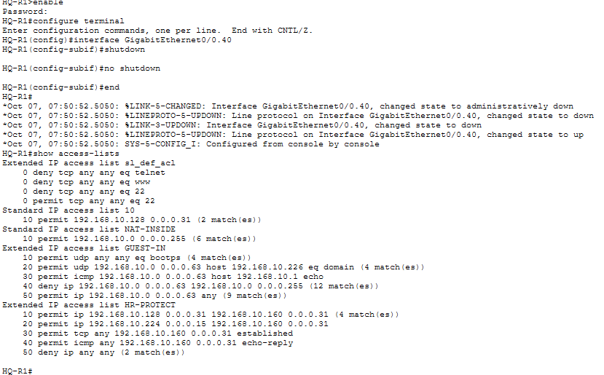
Screenshot 15 - 'show access-lists' on HQ-R1 with match counters after the tests

7.7 Routing protocol security
HQ-R1(config)# interface GigabitEthernet0/1
HQ-R1(config-if)# ip ospf authentication message-digest
HQ-R1(config-if)# ip ospf message-digest-key 1 md5 0SPF-K3y!
With MD5 authentication, a router accepts OSPF packets only if they carry a valid hash of the shared key, so an attacker cannot form an adjacency and inject false routes. Together with passive interfaces this protects the routing table. On the Internet-facing interface CDP is disabled ('no cdp enable') so that device information is not shared with the ISP.

8. Connectivity Testing and Traffic Analysis

8.1 Connectivity test matrix
After all configurations were completed, the following tests were performed from the Command Prompt / Web Browser of the end devices. Each test has an expected result according to the security policy.
# | Source | Destination / Test | Expected | Result | Reason
1 | IT-PC1 | ping HR-PC1 | Success | Success | IT allowed by HR-PROTECT
2 | IT-PC1 | ping SALES-PC1, BR-PC1 | Success | Success | Inter-VLAN routing + OSPF
3 | SALES-PC1 | ping HR-PC1 | Fail | Destination host unreachable | Denied by HR-PROTECT
4 | HR-PC1 | ping SALES-PC1 | Success | Success | echo-reply permitted (HR started it)
5 | BR-PC1 | ping HR-PC1 | Fail | Destination host unreachable | Denied by HR-PROTECT
6 | BR-PC1 | http://intranet.anatolia.local | Success | Intranet page loaded | OSPF + DNS + HTTP
7 | SALES-PC1 | http://www.internet.com | Success | Internet page loaded | DNS + PAT
8 | GUEST-LT1 | http://www.internet.com | Success | Internet page loaded | DNS permitted, Internet permitted
9 | GUEST-LT1 | http://intranet.anatolia.local | Fail | Request timeout | Internal network denied by GUEST-IN
10 | GUEST-LT1 | ping SALES-PC1 | Fail | Destination host unreachable | Denied by GUEST-IN
11 | GUEST-LT1 | ping 192.168.10.1 (gateway) | Success | Success | Explicit permit for troubleshooting
12 | IT-PC1 | ssh -l netadmin 192.168.10.129 | Success | Login with banner | VTY ACL 10 allows VLAN 10
13 | SALES-PC1 | ssh -l netadmin 192.168.10.65 | Fail | Connection refused | VTY ACL 10
14 | IT-PC1 | telnet 192.168.10.129 | Fail | Connection refused | transport input ssh only
15 | IT-PC1 | ssh to HQ-SW1 (.130), BRANCH-SW (.194) | Success | Login | Remote management of switches
16 | ISP router | ping 192.168.10.65 | Fail | Failed | No route to private addresses (NAT)
Table 10 - Connectivity and policy test results
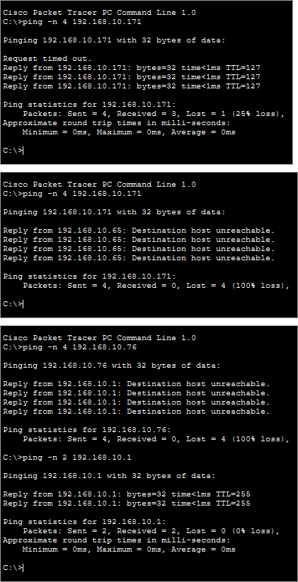
Screenshot 16 - Ping results of tests 1, 3 and 10 (Command Prompt)
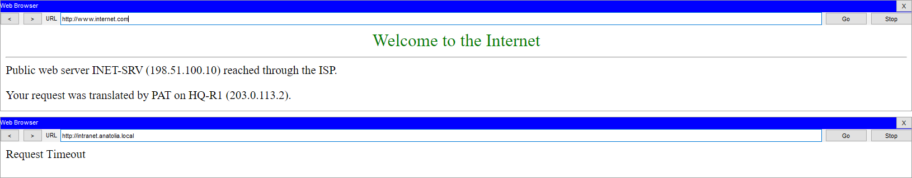
Screenshot 17 - Web browser on GUEST-LT1: www.internet.com loads, intranet.anatolia.local is blocked

8.2 Security attack tests
– Rogue device (port security): To simulate an unauthorized device on an IT port, the MAC address of IT-PC2 was changed to 00E0.F7AB.CDEF and the PC sent traffic. As soon as HQ-SW1 saw the unknown MAC on Fa0/2 it logged %PM-4-ERR_DISABLE and %PORT_SECURITY-2-PSECURE_VIOLATION, put Fa0/2 into err-disabled (Secure-shutdown) state and the link turned red. 'show port-security interface fa0/2' reports a violation count of 1 and the offending MAC address. Recovery: restore the authorized device, then 'shutdown' / 'no shutdown' on the port.
– Rogue DHCP server (DHCP snooping): For this test the switch port of SRV-MGMT (HQ-SW1 Fa0/6, untrusted) was temporarily moved into the HR VLAN 20, the server was given the address 192.168.10.180/27 and its DHCP service was enabled with a fake pool (gateway 192.168.10.190, DNS 8.8.8.8, start 192.168.10.185). HR-PC2 then requested a new address. It still received the legitimate lease from HQ-R1 (192.168.10.172, gateway 192.168.10.161, DNS 192.168.10.226), because DHCP OFFER messages arriving on an untrusted port are discarded by DHCP snooping; only Gi0/1 and Gi0/2 are trusted. Afterwards the port and the server were restored to VLAN 50 / 192.168.10.227.
– Brute-force login: Wrong SSH credentials were entered three times from IT-PC1; HQ-R1 closed the session ('Connection closed by foreign host'), and 'login block-for 120 attempts 3 within 60' blocks further login attempts for 120 seconds. The automatically created quiet-mode ACL sl_def_acl is visible in 'show access-lists'.
– Unauthorized SSH: SSH from SALES-PC1 and BR-PC1 was refused by access-class 10, while IT-PC1 could log in.
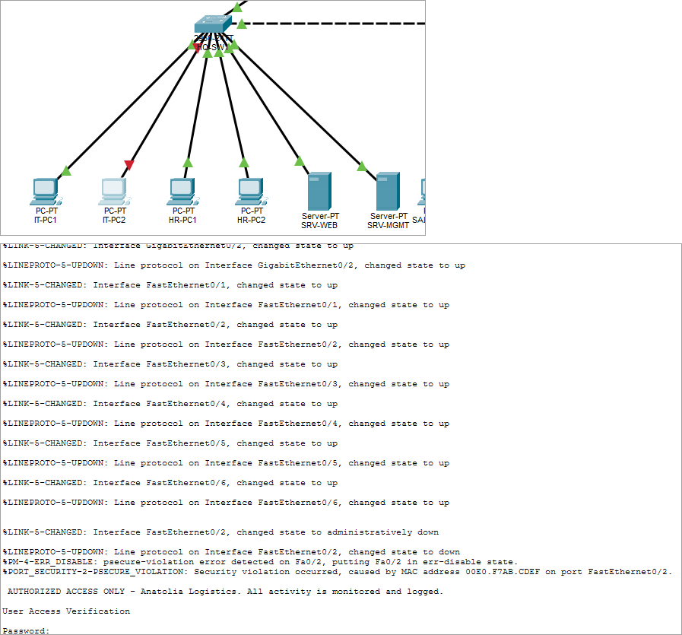
Screenshot 18 - Port-security violation: red link + err-disabled console message

8.3 Traffic analysis in Simulation mode
Packet Tracer Simulation mode was used to follow packets step by step and inspect the OSI layers of each PDU. The event-list filters were set to ARP, DHCP, DNS, HTTP, ICMP, OSPF and TCP.
– DHCP (DORA): When SALES-PC1 is set to DHCP, a DISCOVER broadcast travels from HQ-SW2 over the trunk with an 802.1Q tag of VLAN 30, reaches HQ-R1 G0/0.30, and the router answers with OFFER, the PC sends REQUEST and the router sends ACK. The switches inspected these packets with DHCP snooping.
– ARP and inter-VLAN routing: For the first ping to another VLAN the PC sends an ARP request for its gateway (192.168.10.65). The ICMP frame leaves the PC untagged, gets tag 30 on the trunk, the router changes the tag to 10 and sends it back down the same trunk - this shows router-on-a-stick operation.
– DNS + HTTP: Opening www.internet.com produces a DNS query to 192.168.10.226 (UDP 53), the DNS answer 198.51.100.10, and then the TCP three-way handshake and HTTP GET to port 80.
– NAT: In the PDU details at HQ-R1 the source address changes from the inside local address (e.g. 192.168.10.75) to the inside global address 203.0.113.2 with a new port number; the reply is translated back. 'show ip nat translations' confirms the entries.
– ACL drop: When SALES-PC1 pings HR-PC1, the packet reaches HQ-R1 and is dropped on G0/0.20 outbound; the PDU information shows that the packet matched the deny statement of HR-PROTECT and the router sends an ICMP Destination Unreachable message back.
– OSPF: OSPF Hello packets are seen only on the HQ-R1 - BRANCH-R2 link (not on LANs, because of passive interfaces), and the packet details show authentication type 2 (MD5).
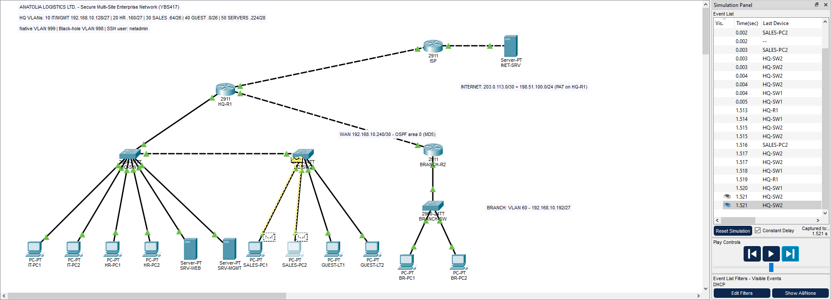
Screenshot 19 - Simulation mode: event list of the DHCP DORA process
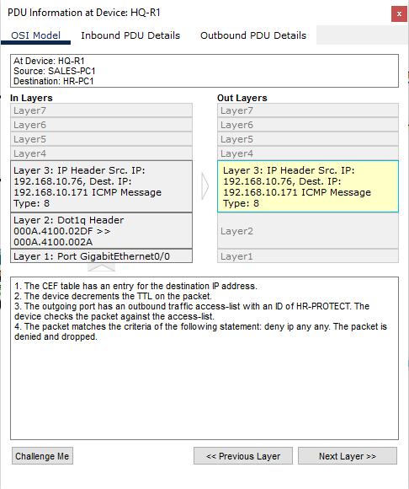
Screenshot 20 - Simulation mode: PDU details showing the ACL drop at HQ-R1
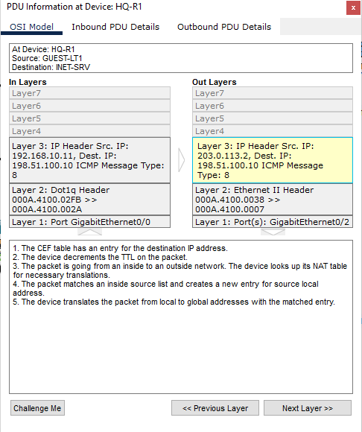
Screenshot 21 - Simulation mode: PDU details showing NAT translation (inside local -> inside global)
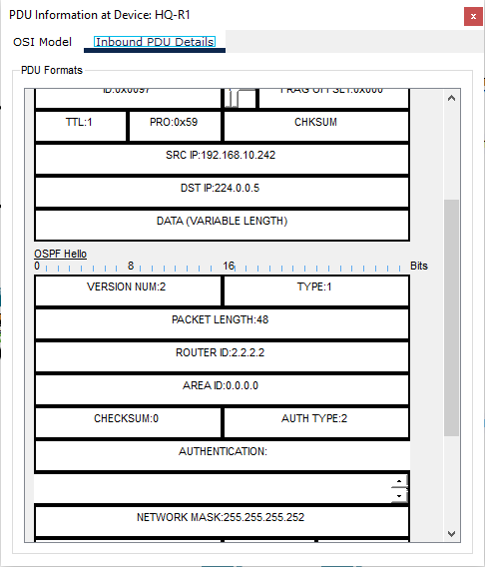
Screenshot 22 - Simulation mode: OSPF Hello PDU with MD5 authentication

8.4 Verification commands
Command | Purpose
show vlan brief / show interfaces trunk | Verify VLAN membership and trunk settings
show ip interface brief | Verify interface addresses and status
show ip route / show ip ospf neighbor | Verify routing and OSPF adjacency
show ip dhcp binding / show ip dhcp snooping | Verify DHCP leases and snooping status
show ip nat translations | Verify PAT translations
show access-lists | Verify ACL entries and match counters
show port-security / show port-security interface fa0/1 | Verify port security status and violations
show ip ssh / show running-config | Verify SSH and overall configuration
Table 11 - Verification commands

9. Challenges and Solutions
Challenge | Cause | Solution
PCs could not get DHCP addresses after DHCP snooping was enabled | Switch inserted option 82 and the router DHCP server rejected the requests; uplinks were untrusted | 'no ip dhcp snooping information option' and 'ip dhcp snooping trust' on uplinks
HR users could not browse the Internet or intranet | Outbound HR-PROTECT dropped the return traffic | Added 'permit tcp ... established' and 'echo-reply' entries
Guests could not resolve web names | GUEST-IN denied all traffic to 192.168.10.0/24 including DNS | Added DNS permit above the deny entry (ACL order matters)
Port went err-disabled when a PC was replaced | Sticky MAC + maximum 1 | Documented the recovery procedure (shutdown / no shutdown, clear sticky address)
SSH could not be enabled | RSA keys require a hostname and domain name | Configured 'ip domain-name' before 'crypto key generate rsa'
Choosing ACL placement | Extended ACLs should be close to the source, but HR must be protected from many sources | GUEST-IN inbound at the Guest source; HR-PROTECT outbound at the HR destination
Table 12 - Challenges and solutions

10. Conclusion
In this project a two-site enterprise network was designed, configured, secured and tested in Cisco Packet Tracer. VLSM allowed a single /24 block to serve seven segments with only 12 spare addresses. Router-on-a-stick, DHCP, OSPF and PAT provided full connectivity between departments, the Branch and the Internet, while the management server gave the IT team logging, time synchronization and configuration backups.
The tests showed that the security policy works as designed: guests can only reach the Internet, the HR VLAN can only be reached by IT and the servers, devices can only be managed with SSH from the IT VLAN, and switch-level attacks (rogue devices, rogue DHCP servers, STP attacks) are blocked. Possible future improvements are first-hop redundancy (HSRP) and a redundant WAN link, a dedicated firewall (Cisco ASA), centralized AAA with a RADIUS/TACACS+ server, a WPA2-Enterprise wireless network for guests and IPv6 dual-stack addressing.

Appendix A - Full Device Configurations
The following command scripts were pasted into the CLI of each device (global configuration mode).

A. HQ-R1
enable
configure terminal
!
! ===== HQ-R1 : Headquarters edge / inter-VLAN router (Cisco 2911) =====
hostname HQ-R1
no ip domain-lookup
ip domain-name anatolia.local
service password-encryption
service timestamps log datetime msec
security passwords min-length 10
enable secret Ent3rpr1se!
username netadmin privilege 15 secret Adm1nP@ss!
login block-for 120 attempts 3 within 60
banner motd # AUTHORIZED ACCESS ONLY - Anatolia Logistics. All activity is monitored and logged. #
!
! ----- SSH -----
crypto key generate rsa general-keys modulus 1024
ip ssh version 2
ip ssh time-out 60
ip ssh authentication-retries 3
!
! ----- Management ACL: only IT/Management VLAN may open VTY sessions -----
access-list 10 remark ALLOW-SSH-FROM-IT-VLAN-ONLY
access-list 10 permit 192.168.10.128 0.0.0.31
!
! ----- Router-on-a-stick sub-interfaces -----
interface GigabitEthernet0/0
description TRUNK-TO-HQ-SW1
no ip address
no shutdown
interface GigabitEthernet0/0.10
description VLAN10-IT-MGMT
encapsulation dot1Q 10
ip address 192.168.10.129 255.255.255.224
ip nat inside
interface GigabitEthernet0/0.20
description VLAN20-HR
encapsulation dot1Q 20
ip address 192.168.10.161 255.255.255.224
ip nat inside
interface GigabitEthernet0/0.30
description VLAN30-SALES
encapsulation dot1Q 30
ip address 192.168.10.65 255.255.255.192
ip nat inside
interface GigabitEthernet0/0.40
description VLAN40-GUEST
encapsulation dot1Q 40
ip address 192.168.10.1 255.255.255.192
ip nat inside
interface GigabitEthernet0/0.50
description VLAN50-SERVERS
encapsulation dot1Q 50
ip address 192.168.10.225 255.255.255.240
ip nat inside
interface GigabitEthernet0/0.999
description NATIVE-VLAN-UNUSED
encapsulation dot1Q 999 native
!
! ----- WAN link to Branch (OSPF with MD5 authentication) -----
interface GigabitEthernet0/1
description WAN-TO-BRANCH-R2
ip address 192.168.10.241 255.255.255.252
ip nat inside
ip ospf authentication message-digest
ip ospf message-digest-key 1 md5 0SPF-K3y!
no shutdown
!
! ----- Internet uplink -----
interface GigabitEthernet0/2
description UPLINK-TO-ISP
ip address 203.0.113.2 255.255.255.252
ip nat outside
no cdp enable
no shutdown
!
! ----- DHCP (HQ VLANs) -----
ip dhcp excluded-address 192.168.10.129 192.168.10.139
ip dhcp excluded-address 192.168.10.161 192.168.10.170
ip dhcp excluded-address 192.168.10.65 192.168.10.74
ip dhcp excluded-address 192.168.10.1 192.168.10.10
ip dhcp pool VLAN10-IT
network 192.168.10.128 255.255.255.224
default-router 192.168.10.129
dns-server 192.168.10.226
domain-name anatolia.local
ip dhcp pool VLAN20-HR
network 192.168.10.160 255.255.255.224
default-router 192.168.10.161
dns-server 192.168.10.226
domain-name anatolia.local
ip dhcp pool VLAN30-SALES
network 192.168.10.64 255.255.255.192
default-router 192.168.10.65
dns-server 192.168.10.226
domain-name anatolia.local
ip dhcp pool VLAN40-GUEST
network 192.168.10.0 255.255.255.192
default-router 192.168.10.1
dns-server 192.168.10.226
domain-name anatolia.local
!
! ----- Routing -----
ip route 0.0.0.0 0.0.0.0 203.0.113.1
router ospf 1
router-id 1.1.1.1
network 192.168.10.0 0.0.0.255 area 0
passive-interface default
no passive-interface GigabitEthernet0/1
default-information originate
exit
!
! ----- NAT / PAT -----
ip access-list standard NAT-INSIDE
permit 192.168.10.0 0.0.0.255
exit
ip nat inside source list NAT-INSIDE interface GigabitEthernet0/2 overload
!
! ----- ACL: Guest isolation (applied IN on VLAN40) -----
ip access-list extended GUEST-IN
remark Allow DHCP requests
permit udp any any eq 67
remark Allow DNS to internal DNS server only
permit udp 192.168.10.0 0.0.0.63 host 192.168.10.226 eq 53
remark Allow ping to own gateway for troubleshooting
permit icmp 192.168.10.0 0.0.0.63 host 192.168.10.1 echo
remark Block guests from every internal subnet
deny ip 192.168.10.0 0.0.0.63 192.168.10.0 0.0.0.255
remark Internet access only
permit ip 192.168.10.0 0.0.0.63 any
exit
!
! ----- ACL: Protect HR VLAN (applied OUT on VLAN20) -----
ip access-list extended HR-PROTECT
remark IT department may reach HR
permit ip 192.168.10.128 0.0.0.31 192.168.10.160 0.0.0.31
remark Servers may reach HR
permit ip 192.168.10.224 0.0.0.15 192.168.10.160 0.0.0.31
remark Return traffic for sessions started by HR
permit tcp any 192.168.10.160 0.0.0.31 established
permit icmp any 192.168.10.160 0.0.0.31 echo-reply
remark Everything else is denied
deny ip any any
exit
!
interface GigabitEthernet0/0.40
ip access-group GUEST-IN in
interface GigabitEthernet0/0.20
ip access-group HR-PROTECT out
exit
!
! ----- Network management: Syslog + NTP -----
logging host 192.168.10.227
ntp server 192.168.10.227
ntp update-calendar
!
! ----- Line security -----
line console 0
password C0ns0leP@ss
login
exec-timeout 5 0
logging synchronous
line vty 0 15
login local
transport input ssh
access-class 10 in
exec-timeout 5 0
end
write memory

A. BRANCH-R2
enable
configure terminal
!
! ===== BRANCH-R2 : Branch office router (Cisco 2911) =====
hostname BRANCH-R2
no ip domain-lookup
ip domain-name anatolia.local
service password-encryption
service timestamps log datetime msec
security passwords min-length 10
enable secret Ent3rpr1se!
username netadmin privilege 15 secret Adm1nP@ss!
login block-for 120 attempts 3 within 60
banner motd # AUTHORIZED ACCESS ONLY - Anatolia Logistics. All activity is monitored and logged. #
!
crypto key generate rsa general-keys modulus 1024
ip ssh version 2
ip ssh time-out 60
ip ssh authentication-retries 3
!
access-list 10 remark ALLOW-SSH-FROM-IT-VLAN-ONLY
access-list 10 permit 192.168.10.128 0.0.0.31
!
interface GigabitEthernet0/0
description BRANCH-LAN
ip address 192.168.10.193 255.255.255.224
no shutdown
interface GigabitEthernet0/1
description WAN-TO-HQ-R1
ip address 192.168.10.242 255.255.255.252
ip ospf authentication message-digest
ip ospf message-digest-key 1 md5 0SPF-K3y!
no shutdown
interface GigabitEthernet0/2
description UNUSED
shutdown
exit
!
ip dhcp excluded-address 192.168.10.193 192.168.10.200
ip dhcp pool BRANCH-LAN
network 192.168.10.192 255.255.255.224
default-router 192.168.10.193
dns-server 192.168.10.226
domain-name anatolia.local
exit
!
router ospf 1
router-id 2.2.2.2
network 192.168.10.192 0.0.0.31 area 0
network 192.168.10.240 0.0.0.3 area 0
passive-interface GigabitEthernet0/0
exit
!
logging host 192.168.10.227
ntp server 192.168.10.227
ntp update-calendar
!
line console 0
password C0ns0leP@ss
login
exec-timeout 5 0
logging synchronous
line vty 0 15
login local
transport input ssh
access-class 10 in
exec-timeout 5 0
end
write memory

A. ISP
enable
configure terminal
!
! ===== ISP : Simulated Internet Service Provider (Cisco 2911) =====
hostname ISP
no ip domain-lookup
enable secret IspS3cret!
banner motd # ISP Router - Authorized access only #
!
interface GigabitEthernet0/0
description CUSTOMER-ANATOLIA-HQ
ip address 203.0.113.1 255.255.255.252
no shutdown
interface GigabitEthernet0/1
description INTERNET-SERVER-LAN
ip address 198.51.100.1 255.255.255.0
no shutdown
end
write memory

A. HQ-SW1
enable
configure terminal
!
! ===== HQ-SW1 : HQ switch - IT, HR, Servers (Cisco 2960-24TT) =====
hostname HQ-SW1
no ip domain-lookup
ip domain-name anatolia.local
service password-encryption
enable secret Ent3rpr1se!
username netadmin privilege 15 secret Adm1nP@ss!
banner motd # AUTHORIZED ACCESS ONLY - Anatolia Logistics. All activity is monitored and logged. #
!
! ----- VLANs -----
vlan 10
name IT-MGMT
vlan 20
name HR
vlan 30
name SALES
vlan 40
name GUEST
vlan 50
name SERVERS
vlan 998
name BLACKHOLE
vlan 999
name NATIVE
exit
!
! ----- Trunks (Gi0/1 -> HQ-R1, Gi0/2 -> HQ-SW2) -----
interface GigabitEthernet0/1
description TRUNK-TO-HQ-R1
switchport mode trunk
switchport trunk native vlan 999
switchport trunk allowed vlan 10,20,30,40,50,999
switchport nonegotiate
ip dhcp snooping trust
no shutdown
interface GigabitEthernet0/2
description TRUNK-TO-HQ-SW2
switchport mode trunk
switchport trunk native vlan 999
switchport trunk allowed vlan 10,30,40,999
switchport nonegotiate
ip dhcp snooping trust
no shutdown
!
! ----- Access ports -----
interface range FastEthernet0/1 - 2
description IT-PCs
switchport mode access
switchport access vlan 10
switchport port-security
switchport port-security maximum 1
switchport port-security mac-address sticky
switchport port-security violation shutdown
spanning-tree portfast
spanning-tree bpduguard enable
no shutdown
interface range FastEthernet0/3 - 4
description HR-PCs
switchport mode access
switchport access vlan 20
switchport port-security
switchport port-security maximum 1
switchport port-security mac-address sticky
switchport port-security violation shutdown
spanning-tree portfast
spanning-tree bpduguard enable
no shutdown
interface range FastEthernet0/5 - 6
description SERVERS
switchport mode access
switchport access vlan 50
switchport port-security
switchport port-security maximum 1
switchport port-security mac-address sticky
switchport port-security violation shutdown
spanning-tree portfast
spanning-tree bpduguard enable
no shutdown
!
! ----- Unused ports: black-hole VLAN + shutdown -----
interface range FastEthernet0/7 - 24
description UNUSED
switchport mode access
switchport access vlan 998
shutdown
exit
!
! ----- DHCP snooping -----
ip dhcp snooping
ip dhcp snooping vlan 10,20,30,40,50
no ip dhcp snooping information option
!
! ----- Management SVI -----
interface vlan 1
shutdown
interface vlan 10
description MGMT
ip address 192.168.10.130 255.255.255.224
no shutdown
exit
ip default-gateway 192.168.10.129
!
crypto key generate rsa general-keys modulus 1024
ip ssh version 2
access-list 10 permit 192.168.10.128 0.0.0.31
!
line console 0
password C0ns0leP@ss
login
exec-timeout 5 0
logging synchronous
line vty 0 15
login local
transport input ssh
access-class 10 in
exec-timeout 5 0
end
write memory

A. HQ-SW2
enable
configure terminal
!
! ===== HQ-SW2 : HQ switch - Sales, Guest (Cisco 2960-24TT) =====
hostname HQ-SW2
no ip domain-lookup
ip domain-name anatolia.local
service password-encryption
enable secret Ent3rpr1se!
username netadmin privilege 15 secret Adm1nP@ss!
banner motd # AUTHORIZED ACCESS ONLY - Anatolia Logistics. All activity is monitored and logged. #
!
vlan 10
name IT-MGMT
vlan 30
name SALES
vlan 40
name GUEST
vlan 998
name BLACKHOLE
vlan 999
name NATIVE
exit
!
interface GigabitEthernet0/1
description TRUNK-TO-HQ-SW1
switchport mode trunk
switchport trunk native vlan 999
switchport trunk allowed vlan 10,30,40,999
switchport nonegotiate
ip dhcp snooping trust
no shutdown
interface GigabitEthernet0/2
description UNUSED
switchport mode access
switchport access vlan 998
shutdown
!
interface range FastEthernet0/1 - 2
description SALES-PCs
switchport mode access
switchport access vlan 30
switchport port-security
switchport port-security maximum 1
switchport port-security mac-address sticky
switchport port-security violation shutdown
spanning-tree portfast
spanning-tree bpduguard enable
no shutdown
interface range FastEthernet0/3 - 4
description GUEST-DEVICES
switchport mode access
switchport access vlan 40
switchport port-security
switchport port-security maximum 1
switchport port-security mac-address sticky
switchport port-security violation shutdown
spanning-tree portfast
spanning-tree bpduguard enable
no shutdown
!
interface range FastEthernet0/5 - 24
description UNUSED
switchport mode access
switchport access vlan 998
shutdown
exit
!
ip dhcp snooping
ip dhcp snooping vlan 30,40
no ip dhcp snooping information option
!
interface vlan 1
shutdown
interface vlan 10
description MGMT
ip address 192.168.10.131 255.255.255.224
no shutdown
exit
ip default-gateway 192.168.10.129
!
crypto key generate rsa general-keys modulus 1024
ip ssh version 2
access-list 10 permit 192.168.10.128 0.0.0.31
!
line console 0
password C0ns0leP@ss
login
exec-timeout 5 0
logging synchronous
line vty 0 15
login local
transport input ssh
access-class 10 in
exec-timeout 5 0
end
write memory

A. BRANCH-SW
enable
configure terminal
!
! ===== BRANCH-SW : Branch office switch (Cisco 2960-24TT) =====
hostname BRANCH-SW
no ip domain-lookup
ip domain-name anatolia.local
service password-encryption
enable secret Ent3rpr1se!
username netadmin privilege 15 secret Adm1nP@ss!
banner motd # AUTHORIZED ACCESS ONLY - Anatolia Logistics. All activity is monitored and logged. #
!
vlan 60
name BRANCH-USERS
vlan 998
name BLACKHOLE
exit
!
interface GigabitEthernet0/1
description UPLINK-TO-BRANCH-R2
switchport mode access
switchport access vlan 60
ip dhcp snooping trust
no shutdown
interface GigabitEthernet0/2
description UNUSED
switchport mode access
switchport access vlan 998
shutdown
!
interface range FastEthernet0/1 - 2
description BRANCH-PCs
switchport mode access
switchport access vlan 60
switchport port-security
switchport port-security maximum 1
switchport port-security mac-address sticky
switchport port-security violation shutdown
spanning-tree portfast
spanning-tree bpduguard enable
no shutdown
interface range FastEthernet0/3 - 24
description UNUSED
switchport mode access
switchport access vlan 998
shutdown
exit
!
ip dhcp snooping
ip dhcp snooping vlan 60
no ip dhcp snooping information option
!
interface vlan 1
shutdown
interface vlan 60
description MGMT
ip address 192.168.10.194 255.255.255.224
no shutdown
exit
ip default-gateway 192.168.10.193
!
crypto key generate rsa general-keys modulus 1024
ip ssh version 2
access-list 10 permit 192.168.10.128 0.0.0.31
!
line console 0
password C0ns0leP@ss
login
exec-timeout 5 0
logging synchronous
line vty 0 15
login local
transport input ssh
access-class 10 in
exec-timeout 5 0
end
write memory

Appendix B - Lab Credentials
These credentials are used only in this laboratory environment.
Item | Value
Enable secret (all Cisco devices except ISP) | Ent3rpr1se!
SSH user / password | netadmin / Adm1nP@ss!
Console password | C0ns0leP@ss
OSPF MD5 key (key 1) | 0SPF-K3y!
ISP enable secret | IspS3cret!

